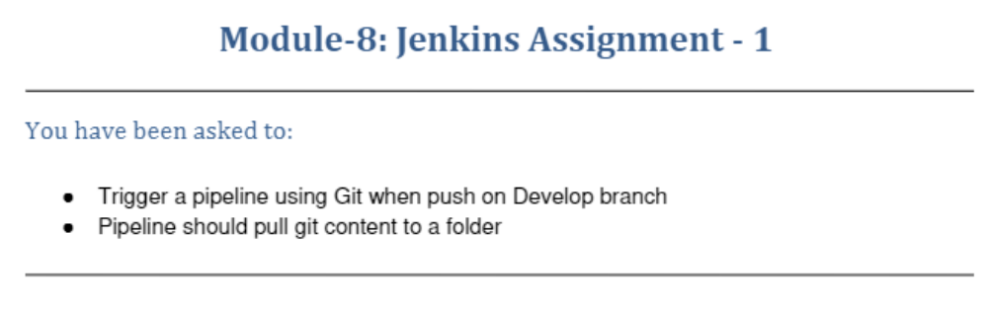
Jenkins-slave connected to the Jenkins-master
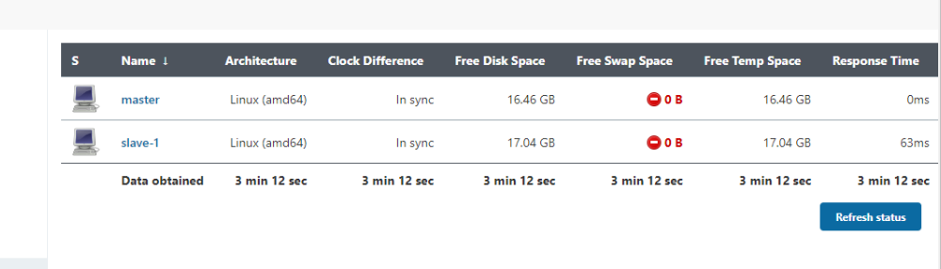
ubuntu@ip-172-31-33-19:~$ ls
jenk.txt
ubuntu@ip-172-31-33-19:~$ git init
Reinitialized existing Git repository in /home/ubuntu/.git/
ubuntu@ip-172-31-33-19:~$ git status
On branch master
Changes not staged for commit:
(use "git add <file>..." to update what will be committed)
(use "git restore <file>..." to discard changes in working directory)
modified: .Xauthority
modified: .bash_history

Untracked files:
(use "git add <file>..." to include in what will be committed)
.ssh/known_hosts

no changes added to commit (use "git add" and/or "git commit -a")
ubuntu@ip-172-31-33-19:~$ git remote add origin "git@github.com:vcgatate/myproject.git"
fatal: remote origin already exists.
ubuntu@ip-172-31-33-19:~$ git add .
ubuntu@ip-172-31-33-19:~$ git commit -m "finalbuilt"
[master 629ee7d] finalbuilt
Committer: Ubuntu <ubuntu@ip-172-31-33-19.us-east-2.compute.internal>
Your name and email address were configured automatically based
on your username and hostname. Please check that they are accurate.
You can suppress this message by setting them explicitly. Run the
following command and follow the instructions in your editor to edit
your configuration file:

git config --global --edit

After doing this, you may fix the identity used for this commit with:

git commit --amend --reset-author

3 files changed, 14 insertions(+)
create mode 100644 .ssh/known_hosts
ubuntu@ip-172-31-33-19:~$ git push origin master

On slave machine
ubuntu@ip-172-31-23-223:~$ ls
agent.jar agent.jnlp jenkins 'jenkins'$'\n' jenkins-agent.jnlp remoting secret-file
ubuntu@ip-172-31-23-223:~$ cd jenkins
ubuntu@ip-172-31-23-223:~/jenkins$ ls
remoting secret-file workspace
ubuntu@ip-172-31-23-223:~/jenkins$ cd workspace/
ubuntu@ip-172-31-23-223:~/jenkins/workspace$ ls
'Build Git-job' Git-job
ubuntu@ip-172-31-23-223:~/jenkins/workspace$ cd Git-job/
ubuntu@ip-172-31-23-223:~/jenkins/workspace/Git-job$ ls
3.txt 4.txt 5.txt 6.txt config.json main.java
ubuntu@ip-172-31-23-223:~/jenkins/workspace/Git-job$

